Course Handbook
Applied AI and Automation for Executives | KLAi Professional Learning, Kampala | Instructor: Jotham Martin Wambi
This handbook is yours to keep. It gives you the words and the pictures behind the course, so that you arrive at Session 1 able to follow every idea, and so that you can come back to it whenever a term needs a reminder. Read it in any order. Parts 3 to 15 explain how AI works and how to judge it. Part 16 tells you what to prepare. Part 17 is a glossary. Part 18 is the twelve sessions on one page.
What is inside
Part | Title
1 | Welcome and how the course works
2 | Why this first session matters
3 | AI, machine learning, deep learning and generative AI
4 | How machines learn
5 | How a model is trained
6 | Data: the fuel and the risk
7 | Language models and generative AI
8 | Where AI is used in industry, and what suits it
9 | How we know a model is good
10 | Benchmarks
11 | Training and inference
12 | What happens when you press send
13 | Foundation models, open models, fine-tuning and cost
14 | Is our data ready for AI?
15 | From model to working product: workflows, agents and tools
16 | Before Session 1
17 | Glossary
18 | The twelve sessions at a glance

A note on simplification
This handbook explains ideas in plain words. Where it simplifies, it says so with the word "simplified". The simple version is correct enough to make good decisions. Specialists add detail that you do not need for the work of this course.
All company names and figures in examples are fictional or general. The handbook contains no statistics.

Part 1
Welcome and how the course works
The course has twelve sessions of two hours each, 24 hours in all. You choose the dates and the place with the instructor: in person, online or at your workplace. The group is small, from one to five executives, so the time is spent on your company.
One task from your own company
In Session 1 you choose one real task that recurs in your company: a weekly report, a stream of customer messages, a pile of invoices, a set of contracts. This is your own task. It stays with you for all twelve sessions. You measure it, test an AI tool on it, brief the tool, prepare its information, build an automation for it, set limits, count the savings and write the business case. Nothing is left as theory.
No tests and no marks
There are no tests, no marks and no required homework. You show progress by what you build and keep. Anything you do between sessions is optional.
What you keep
• A written AI-use policy for your company.
• Two or three working automations.
• A costed business case and a 90-day roadmap.
• A set of templates, one for each session, filled in for your own task.
• The confidence to question a vendor and to supervise a pilot.
The two build tools
You see two example automations at work, both on the same customer messages. In Session 6 the messages are routed by plain rules, in a spreadsheet and in a no-code automation tool such as Zapier. In Session 8 an AI assistant sorts the same messages and drafts replies, and a person checks them. You do not need to build either. The hands-on work is about your own company: choosing the right workflow, checking how ready your data is, writing your AI use policy and planning your data roadmap. Other tools exist and we compare them in Part 15 and in Sessions 7 and 10, so that you can choose well.
After the course
The instructor follows up with you at 30, 60 and 90 days. You return a one-page check-in form and a results tracker. The follow-up asks what is running, how much time it saves and what changed in your policy.
How a session runs
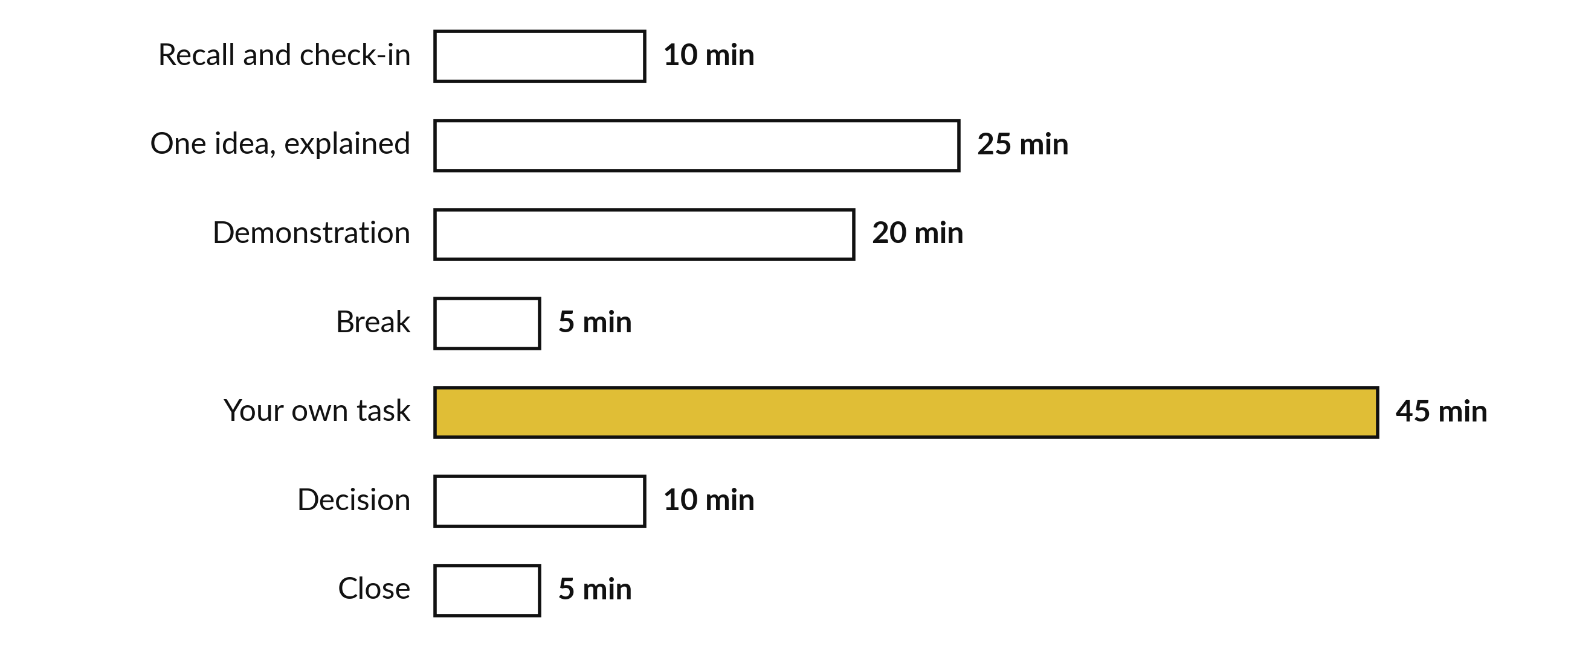
The usual shape of a two-hour session. Sessions 6 and 8 are build sessions with more time for your own build.

Part 2
Why this first session matters
You cannot judge a claim, a vendor or a result unless you have the words and a picture of how the thing works. A vendor who says "our model learns from your data" or "the agent acts on its own" is saying something specific. With the picture in your head you can ask what data, learns how, and acts on what. Without the picture you can only nod.
This handbook gives you that picture once. Every idea in it comes back later in the course, applied to your own task.
Idea in this handbook | Where it returns
Training, error and adjusting | Session 2: why a tool is right most of the time and wrong some of the time
Training, validation and test data | Session 2 (testing for mistakes) and Session 8 (measuring against a baseline)
Data types and data quality | Session 4: your information inventory
Privacy and bias | Sessions 4 and 9: sensitivity marks, risk register, policy
Language models, tokens, context window | Session 3: how to brief a tool and check what it returns
Hallucination and retrieval | Sessions 3 and 5: source-linked document review
Prompt injection | Sessions 7 and 9: limits on what an automation may do
Workflow, trigger and human in the loop | Sessions 6 and 8: the two demonstrated automations
Agents and limits | Session 7: the tool boundary sheet
Baseline, pilot and ROI | Sessions 8 and 11: measurement and the business case
Vendor and model terms | Session 10: questions for vendors

Part 3
AI, machine learning, deep learning and generative AI
These four terms are often used as if they mean the same thing. They do not. Each is a smaller part of the one before, like boxes that sit inside each other.
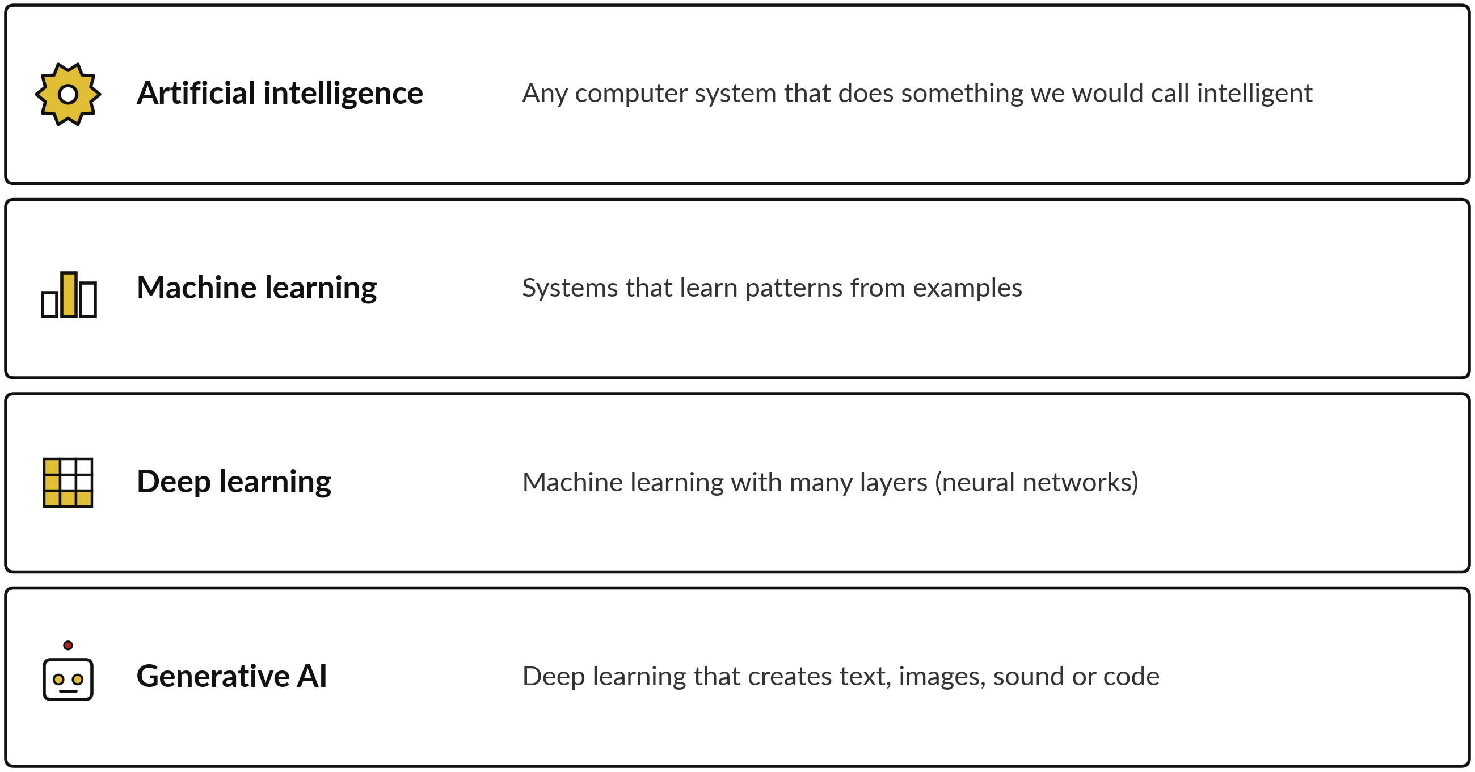
The nested picture. Each layer is part of the one above it. Simplified: the boundaries are fuzzy in practice.
Term | A business example
Artificial intelligence (AI) | A set of written rules that approves a mobile money transfer only if the amount is under a limit and the account is verified. This is old-style AI: people wrote the rules.
Machine learning (ML) | A fraud detector that has studied thousands of past transactions marked "fraud" or "fine" and learned which patterns tend to go with fraud. Nobody wrote the rules by hand.
Deep learning | A system that reads a photo of a maize leaf and tells you which disease it has. It uses a neural network with many layers, which suits photos, sound and language.
Generative AI | An assistant that drafts a reply to a customer, summarises a board meeting or writes a first version of a policy. It generates something new each time.

Most of what you will use in this course is generative AI, built on deep learning, which is a kind of machine learning, which is a part of AI. When a vendor says "AI", ask which of the four they mean.

Part 4
How machines learn
A machine learns from experience, which for a machine means data. There are four main ways of learning. Each suits a different business problem.
Way of learning | In plain words | A business example
Supervised learning | The machine studies examples that come with the right answer (a label). It learns to give the right answer for new cases. | Classification: sort invoices into "fine" or "needs checking".  Regression: predict next month's sales of cooking oil from the past.
Unsupervised learning | No right answers are given. The machine looks for structure and finds groups on its own. | Grouping 300 shops into types of buyer by how and when they order, so that each type gets a different offer.
Reinforcement learning | The machine tries actions and receives a reward or a penalty. Over many tries it learns which actions pay off. | Choosing delivery routes: each route that saves fuel and arrives on time earns a reward.
Self-supervised learning | The machine makes its own exercise out of raw data by hiding part of it and guessing it. For text, the hidden part is the next word. | The base of language models. Reading huge amounts of text and guessing the next word, again and again, is how they learn language.

Two words you will meet often
• Classification gives a category as the answer: spam or not spam, fraud or fine, urgent or routine.
• Regression gives a number as the answer: next week's demand, the likely delivery time, the price.
• Clustering is the unsupervised cousin: it makes the groups itself, without being told the categories.
Simplified: real systems often mix these ways. A language model, for example, learns by self-supervised learning first and is then improved with other methods (Part 7).

Part 5
How a model is trained
A model is a program whose behaviour comes from numbers it has learned. No person typed in the rules. Training is the process of finding good numbers. It follows one loop, repeated millions of times.
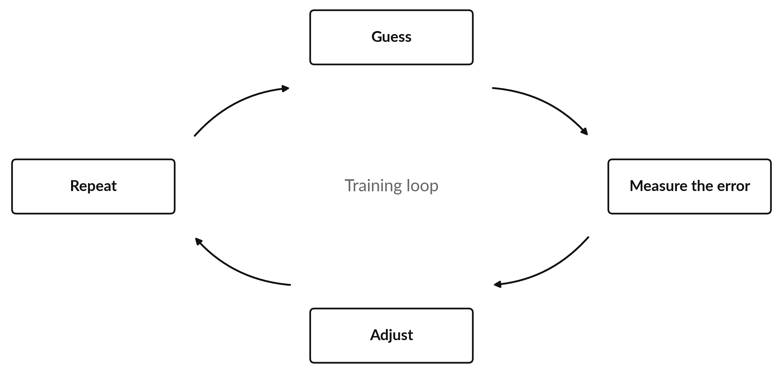
The training loop. The error has a technical name, the loss. A smaller loss means better guesses.
Parameters and weights
The numbers a model learns are called parameters. Many of them are called weights: each weight says how strongly one piece of information should influence the answer, like the volume knob on one input. A small model may have thousands of weights. The large language models behind today's assistants have billions. Training sets all of them.
Gradient descent: walking downhill in fog
Imagine you stand on a hill in thick fog and want to reach the lowest point. You cannot see the valley. You feel the slope under your feet and take a small step downhill. Then you feel the slope again and take another step. Eventually the ground stops falling and you are at a low point. Gradient descent does exactly this. The "hill" is the error. The "step" is a small change to the weights. Each step makes the error a little smaller.
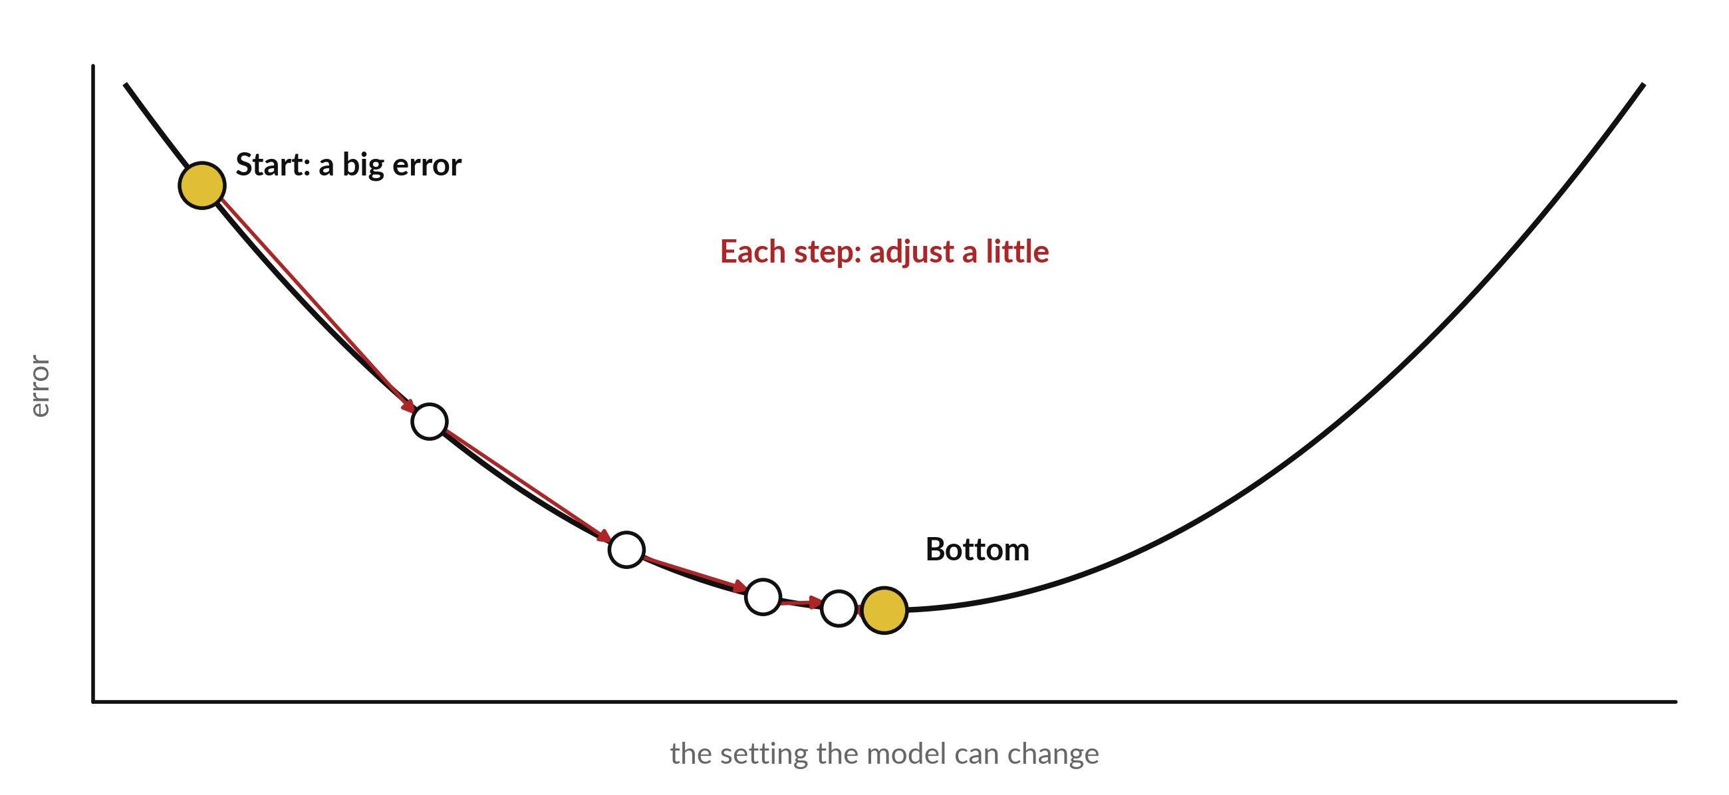
Gradient descent. At the bottom the error is the smallest the model has found. Simplified: the real hill has millions of directions, and the lowest point found is usually a good one rather than the best possible.
Backpropagation: sharing out the blame
A neural network has layers, and an answer passes forward through all of them. When the answer is wrong, which weight is to blame? Backpropagation works that out. It starts from the error at the output and moves backward through the layers, sharing out the blame: weights that contributed more to the mistake get changed more, weights that contributed less get changed less. Then the next guess is made with the adjusted weights.
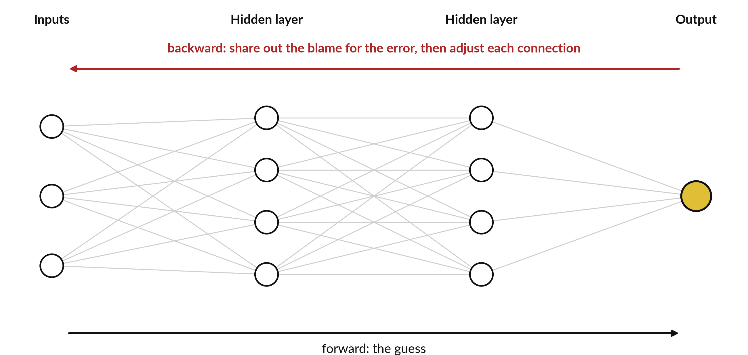
Forward the network guesses. Backward it shares out the blame and adjusts every connection.
Why training needs data and computing power
The model improves only by seeing many examples, so it needs a lot of data. Each guess, error measure and adjustment is a calculation, and a large model needs a huge number of them. That takes powerful specialised computers running for days or weeks. This is why only a few organisations train the largest models, and why most companies use a model someone else trained.
Training, validation and test data
You do not judge a model on the examples it studied. You split the data into three parts.
Part | What it is for
Training data | The examples the model learns from. Most of the data goes here.
Validation data | Examples set aside while building. The builder uses them to compare versions and to tune settings, and they are not used for learning.
Test data | A locked set, used once at the end to see how the final model does on cases it has never met. Nobody tunes the model on it, because then it would no longer be a fair check.

Overfitting: a model that memorises
A student who memorises last year's answers does well on last year's paper and badly on a new one. A model can do the same. It can learn the training examples so closely, including their accidents and noise, that it has not learned the general pattern. This is overfitting.
This is why a model that is 99 percent right on its training data can still fail on new data. The 99 percent only says it remembers what it saw. The test data answers the real question: how does it do on cases it has not seen? A fair result on the locked test data means more than any score on the training data. Keep this in mind when anyone shows you a very high accuracy figure: ask which data it was measured on.

Part 6
Data: the fuel and the risk
Every AI system depends on data. Knowing what kind of data you hold, and how good it is, decides what AI can do for you.
Kinds of data
Kind | What it looks like | In a company
Structured | Fits neatly in rows and columns with fixed fields. | A sales sheet, an invoice register, a stock list
Semi-structured | Has some labels or layout but no fixed table. | Emails with sender, date and subject; forms; many exported files
Unstructured | Free-form content without a table. | Photos of damaged goods, voice recordings of calls, contracts, WhatsApp messages
Time series | Values recorded in time order. The order matters. | Daily sales, truck fuel readings, temperature sensor readings in a cold store

Data can also be labelled or unlabelled. Labelled data carries the right answer: an email marked "complaint", an invoice marked "wrong total". Unlabelled data has no answer attached. Labelled data is needed for supervised learning and is usually costly, because a person has to do the marking.
Data quality: five questions
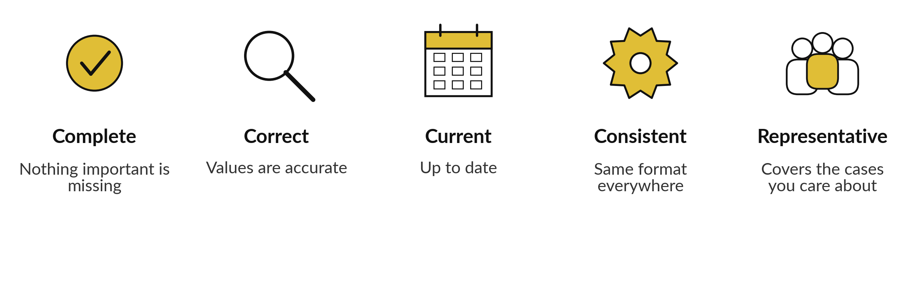
A tool fed with poor data gives poor answers, quickly and with confidence. A simple example: sales data where half the shops write "Mbale" and half write "MBL" will be counted as two places.
Bias and where it enters
A model reflects the data it learned from. Bias means a systematic tilt that treats some cases or groups unfairly. It can enter at four points:
• In the data collected. If past hiring favoured one kind of candidate, a model trained on it will too.
• In the labels. If people marked past cases unfairly, the model copies the marks.
• In who is missing. If few rural customers are in the data, the model serves them badly.
• In how the result is used. A sensible score used for a purpose it was not built for can still do harm.
Privacy and the law in Uganda
Data about identifiable people (names, phone numbers, ID numbers, health or pay details) is personal data. In my understanding, the Data Protection and Privacy Act 2019 applies to personal data, including when it goes into an AI tool; confirm your company's duties with a lawyer. Session 4 and Session 9 turn this into practical rules for your company.

Part 7
Language models and generative AI
The assistants you use, such as ChatGPT, Claude, Gemini and Copilot, are built on large language models. A language model is a model trained on a very large amount of text to predict what comes next.
Tokens and the next-word idea
A model does not read whole words. It splits text into small pieces called tokens. A token may be a short word, part of a long word or a punctuation mark. Given the tokens so far, the model works out which token is most likely to come next, adds it, and repeats. An answer of a hundred words is built one token at a time. Simplified: it chooses among likely tokens with a little controlled randomness, which is why the same question can give different answers.
How a language model gets built
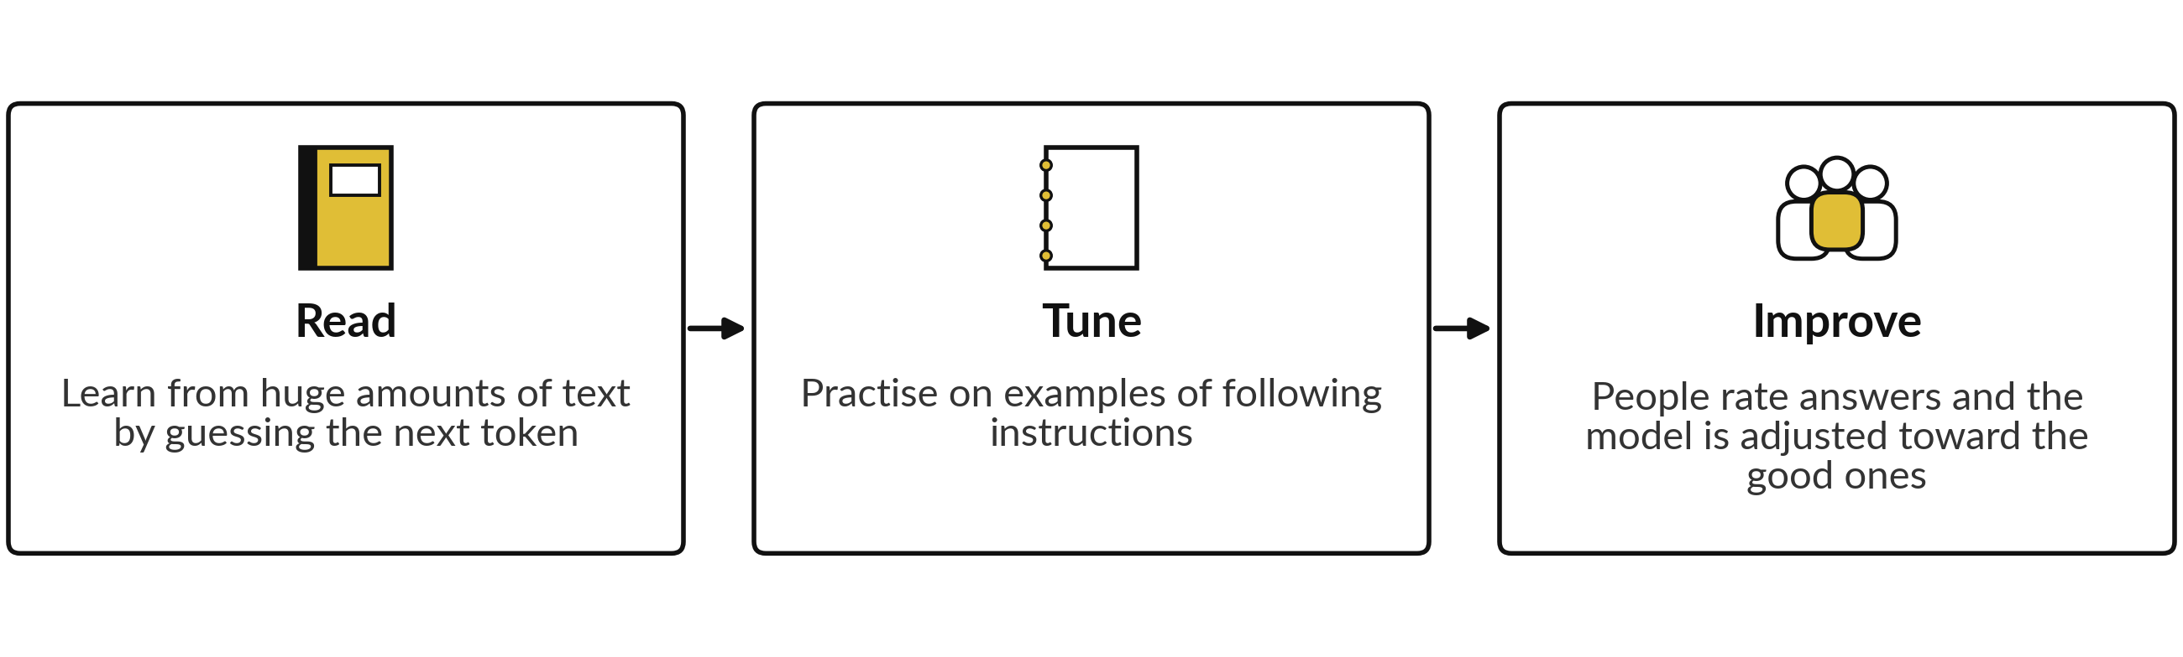
Three stages in plain words. The third is often called human feedback. Simplified: companies combine several methods.
Context window
The context window is how much text the model can keep in view at once: your question, any files you give it, and its own answer so far. It is like the desk the model works on. If a document is larger than the desk, parts fall off, and the model may miss or mix them up. Windows are now large, but a bigger desk does not guarantee that the model attends to every part equally well.
Why a model can sound sure and be wrong
The model is built to produce text that reads well and fits the pattern. It is not built to check facts. When it lacks the information, it can still write a smooth, confident sentence that is false. This is called a hallucination. It can include invented figures, names, quotes and sources. The tone does not tell you whether it is right. This is why the course teaches you to ask for sources, to check, and to test your own task for mistakes (Session 2).
What changes with search, files and memory
On its own, a model answers from what it learned in training, which stops at a date and knows nothing about your company. Assistants can add three things.
• Search. The assistant looks up the web and writes from what it found. You can open the sources.
• Files. You give it a document and it answers from that document.
• Memory. Some assistants keep notes about you between chats. Check what is kept and who can see it.
Giving the model the right passages from your own documents before it answers is called retrieval. Think of an open-book answer: the assistant finds the relevant pages first and then writes from them. This cuts down mistakes, but does not remove them: the retrieval can fetch the wrong page, and the model can still misread the right one. Always check the answer against the source.

Part 8
Where AI is used in industry
AI is used wherever there is a lot of data, a repeated decision and a cost to getting it wrong or slow. These are general examples of where it is used. They contain no statistics.
Sector | Typical uses
Banking and mobile money | Spotting unusual transactions that may be fraud; estimating the risk that a borrower will not repay; answering customer questions.
Agriculture | Recognising crop diseases and pests from photos; forecasting yield and market prices; advising farmers by message.
Retail and distribution | Forecasting demand for each product and shop; planning delivery routes; setting reorder points.
Health administration | Scheduling and reminders; sorting and coding records; drafting letters. Clinical decisions stay with clinicians.
Human resources | Sorting applications and drafting job adverts. Screening carries a bias risk, so a person must review the outcome.
Customer service | Sorting incoming messages, drafting replies, finding the right policy page for the agent.
Finance and accounting | Matching invoices to purchase orders; flagging duplicates and wrong totals; drafting management commentary.

What suits AI and what does not
Work comes in four kinds. Knowing which kind you have tells you which tool to reach for.
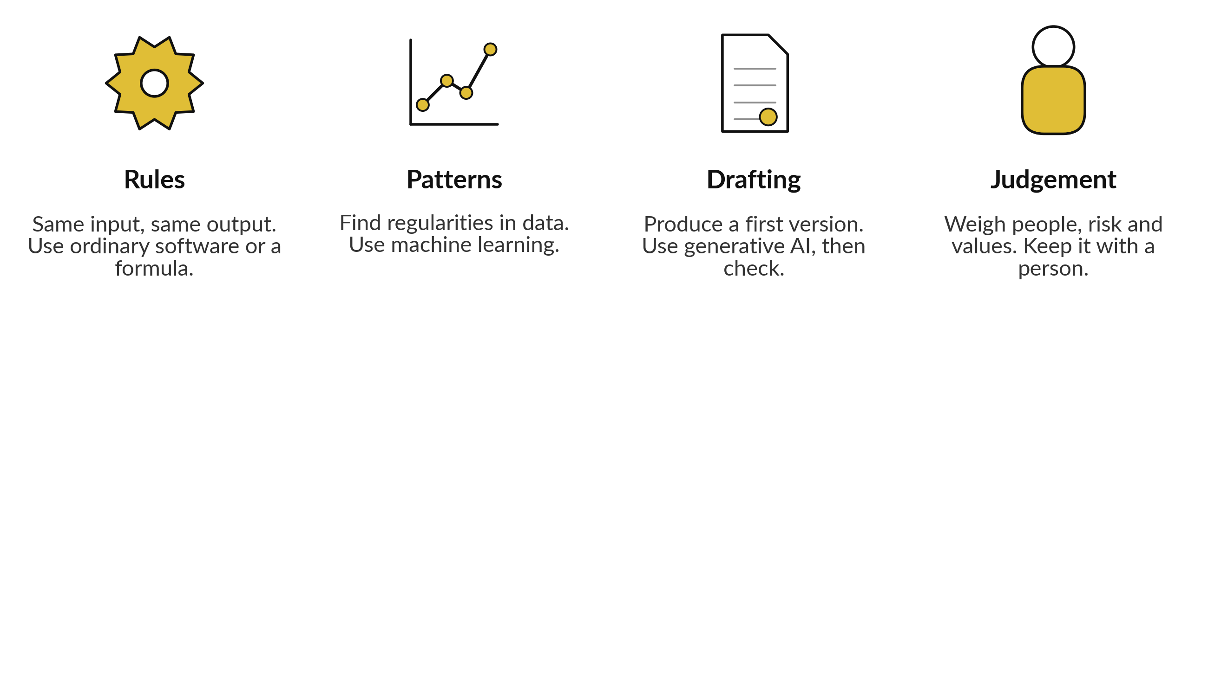
A good first task for AI is one with a clear pattern or a draft to produce, where a person can check the result quickly and a mistake is cheap to catch. A poor first task has a high cost of error, little data and nobody to check. Session 1 gives you a scorecard for this choice. A rule is often better done with a formula, which is cheaper, faster and always the same.
The fields of AI
AI is not one skill. It is a set of fields, and each one suits a different business problem. A vendor who says they do AI should be able to say which field they work in.
Field | What it does | In a company
Natural language processing (NLP) | Reads and writes human language: summarising, sorting, translating, answering. | Summarise emails, sort enquiries, draft replies.
Computer vision | Understands images and video. | Read invoices, check goods in photos, count stock.
Speech | Turns speech into text and text into speech. | Transcribe meetings and calls.
Forecasting (time series) | Predicts numbers over time from past values. | Demand, cash flow, prices.
Recommendation | Suggests what a person may want next. | Product suggestions, next best offer.
Anomaly detection | Spots what does not fit the usual pattern. | Fraud alerts, faulty machines.
Deep learning | A family of methods using large neural networks, behind most progress in language, vision and speech. | Inside most of the tools above.
Generative AI | Creates new text, images, audio or code. | Draft reports, replies and code.
Reinforcement learning | Learns by trial and reward. | Route planning, dynamic pricing, robots.

The jobs behind AI work
Titles vary between companies, and in a small company one person often does several of these jobs. This is the usual division.
Role | What they do | Where you meet it
Data engineer | Builds and runs the pipes that bring clean data in. | Session 4
Data analyst | Explains what happened, with tables and charts. | Sessions 1 and 11
Data scientist | Builds and tests models that predict or classify. | Session 10
Machine learning engineer | Turns a model into a reliable product; deploys and monitors it. | Sessions 7 and 9
MLOps engineer | Builds the systems that train, release and monitor models. | Session 9
Applied AI engineer | Builds products from ready-made models with prompts, retrieval, automations and agents. | Sessions 3 to 8
AI researcher | Invents new methods, usually in universities or large labs. | Not needed to start
Data steward or information manager | Owns the quality and the rights of the data: who may use it, how it is kept and how it is corrected. | Session 4
Product owner or AI governance lead | Chooses use cases, sets the rules and checks the value. | Sessions 9 to 12: your seat

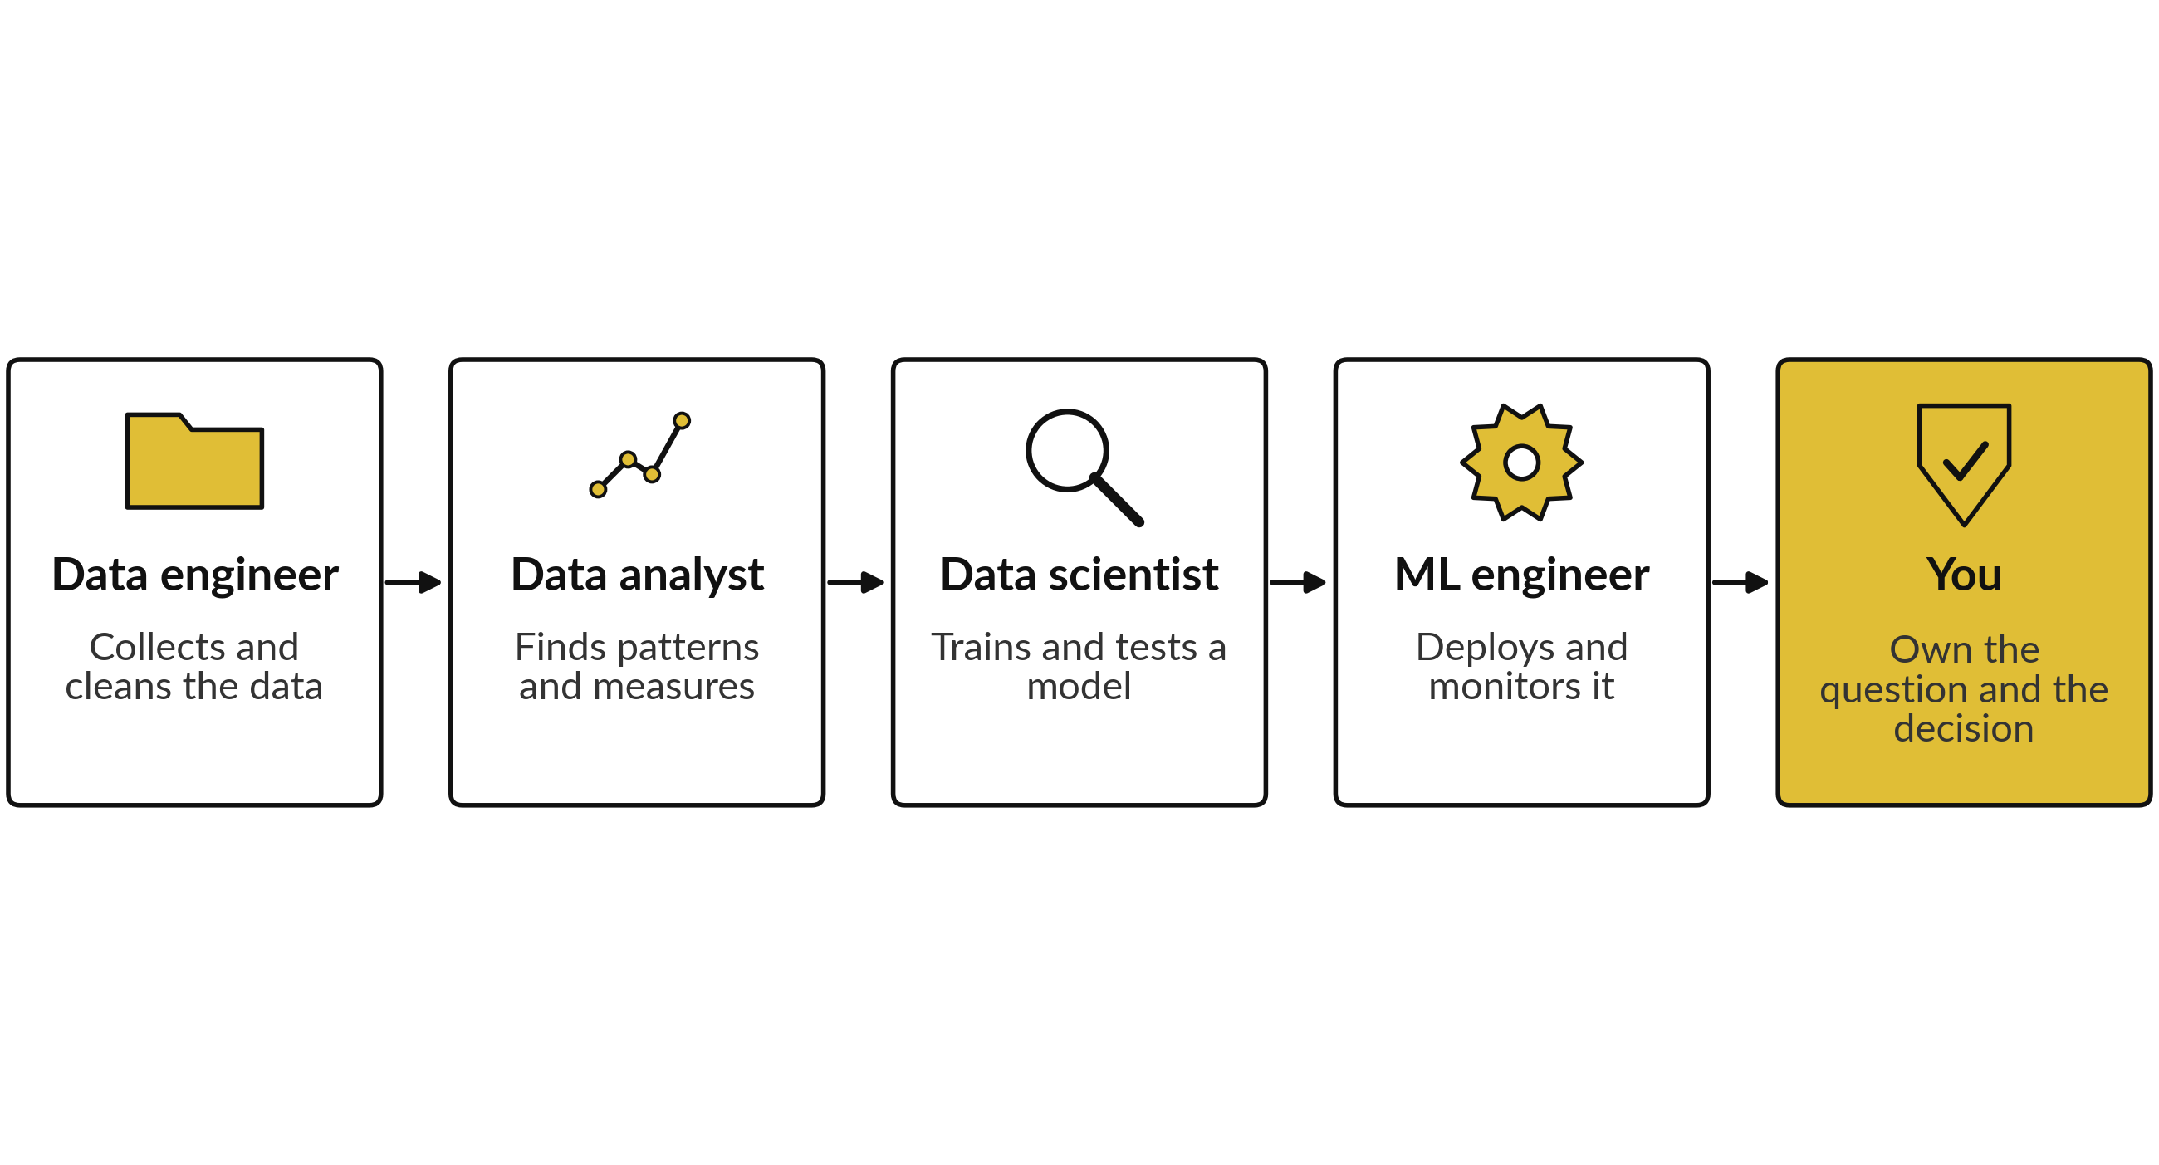
The roles hand work along a line. At every step a leader owns the question, the rules and the decision. If your company has none of these people, you can still do useful work with ready-made tools, which is what the build sessions show.

Part 9
How we know a model is good
Every vendor quotes a number: "95 percent accurate", "an AUC of 0.9". This part gives you the words to read those numbers and the questions to ask about them. All figures in this part are illustrative.
Accuracy, and why it can mislead
Accuracy is the share of all cases the model got right. It sounds like the whole story, and for rare events it is not. If one transaction in a hundred is fraud, a model that calls every transaction "fine" is right 99 times in 100 and catches no fraud at all. A high accuracy can hide a useless model, so we look at the kinds of right and wrong.
The confusion matrix
For a model that sorts cases into two groups, such as fraud and fine, every case lands in one of four boxes. The table of the four boxes is the confusion matrix.
Box | What it means
True positive (TP) | The model says fraud, and it is fraud. A catch.
False positive (FP) | The model says fraud, and it is fine. A false alarm.
False negative (FN) | The model says fine, and it is fraud. A miss.
True negative (TN) | The model says fine, and it is fine. A correct pass.

One worked example (illustrative)
A fraud model checks 1,000 transactions. In truth, 10 are fraud. The model raises 20 alerts. Of the 20 alerts, 8 are real fraud and 12 are false alarms. It misses the other 2 frauds. The remaining 978 are correctly passed. These numbers are made up to show the arithmetic.
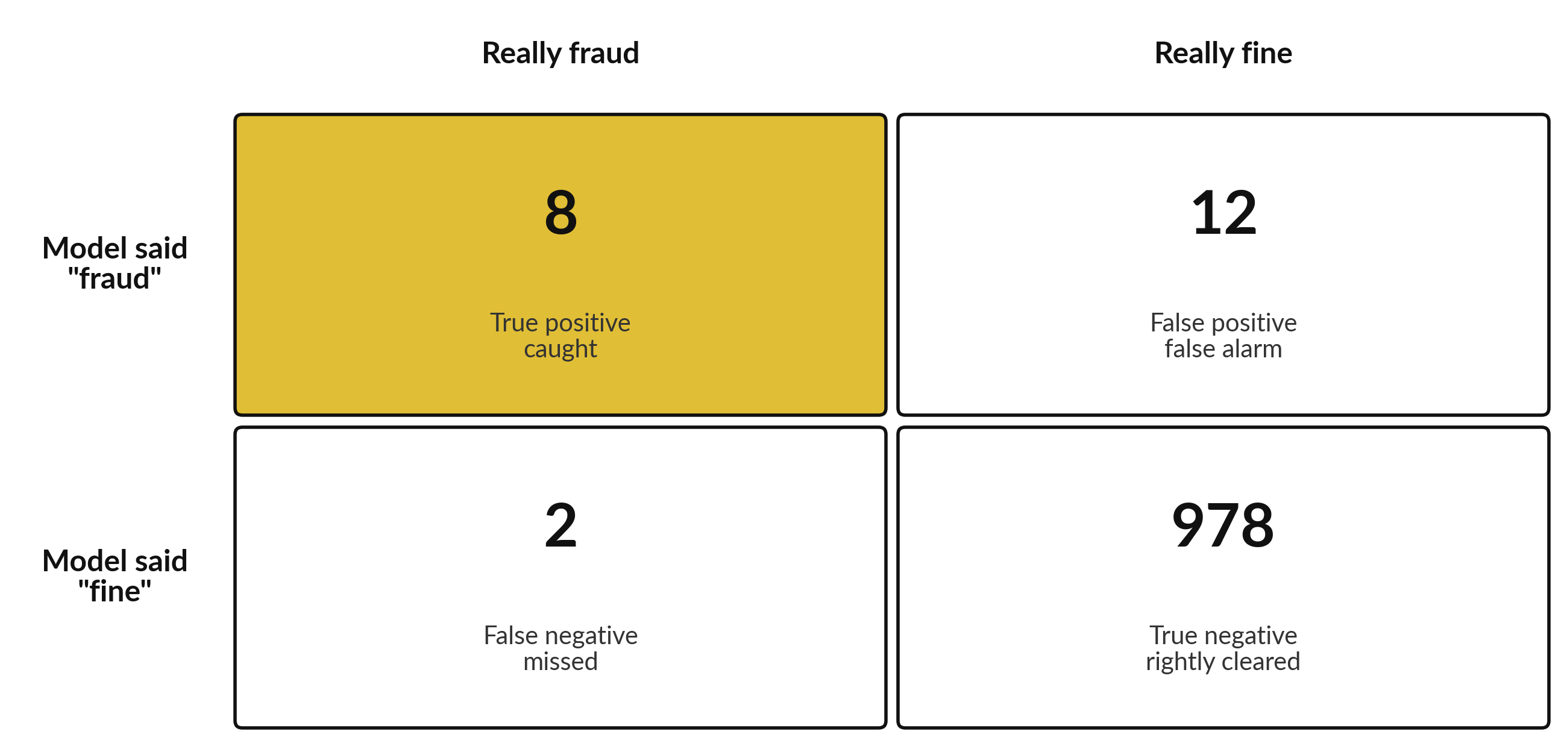
Illustrative confusion matrix for a fraud model on 1,000 transactions.
Measure | The question it answers | Arithmetic | Result
Accuracy | Right answers out of all cases | (8 + 978) / 1,000 = 986 / 1,000 | 98.6 percent
Precision | Of the alerts raised, how many were real | 8 / (8 + 12) = 8 / 20 | 40 percent
Recall | Of the real frauds, how many were caught | 8 / (8 + 2) = 8 / 10 | 80 percent
F1 | One number that balances precision and recall | 2 x 0.40 x 0.80 / (0.40 + 0.80) = 0.64 / 1.20 | about 53 percent

The accuracy of 98.6 percent looks excellent. Yet only 40 percent of the alerts are real, so the fraud team spends most of its day on false alarms, and one fraud in five still gets through. Precision protects your staff time. Recall protects your money. Which one matters more depends on what a false alarm and a miss cost you.
The threshold
Most models give a score, for example "0.73 likely to be fraud". The threshold is the score above which you raise an alert. Set it low and you catch more fraud (recall rises) but raise more false alarms (precision falls). Set it high and the reverse happens. The threshold is a business decision about cost, and the data scientist should not choose it alone.
The ROC curve and AUC
The ROC curve shows what happens as you slide the threshold from high to low. It plots the share of real frauds caught against the share of fine cases wrongly flagged. A curve that bows toward the top left corner is a better model. The area under the curve is called AUC. An AUC of 0.5 is a coin flip, and 1.0 is perfect. In the illustration below the AUC is about 0.86. When fraud is very rare, the precision-recall curve is the more honest picture, because it shows how many of the alerts are real.
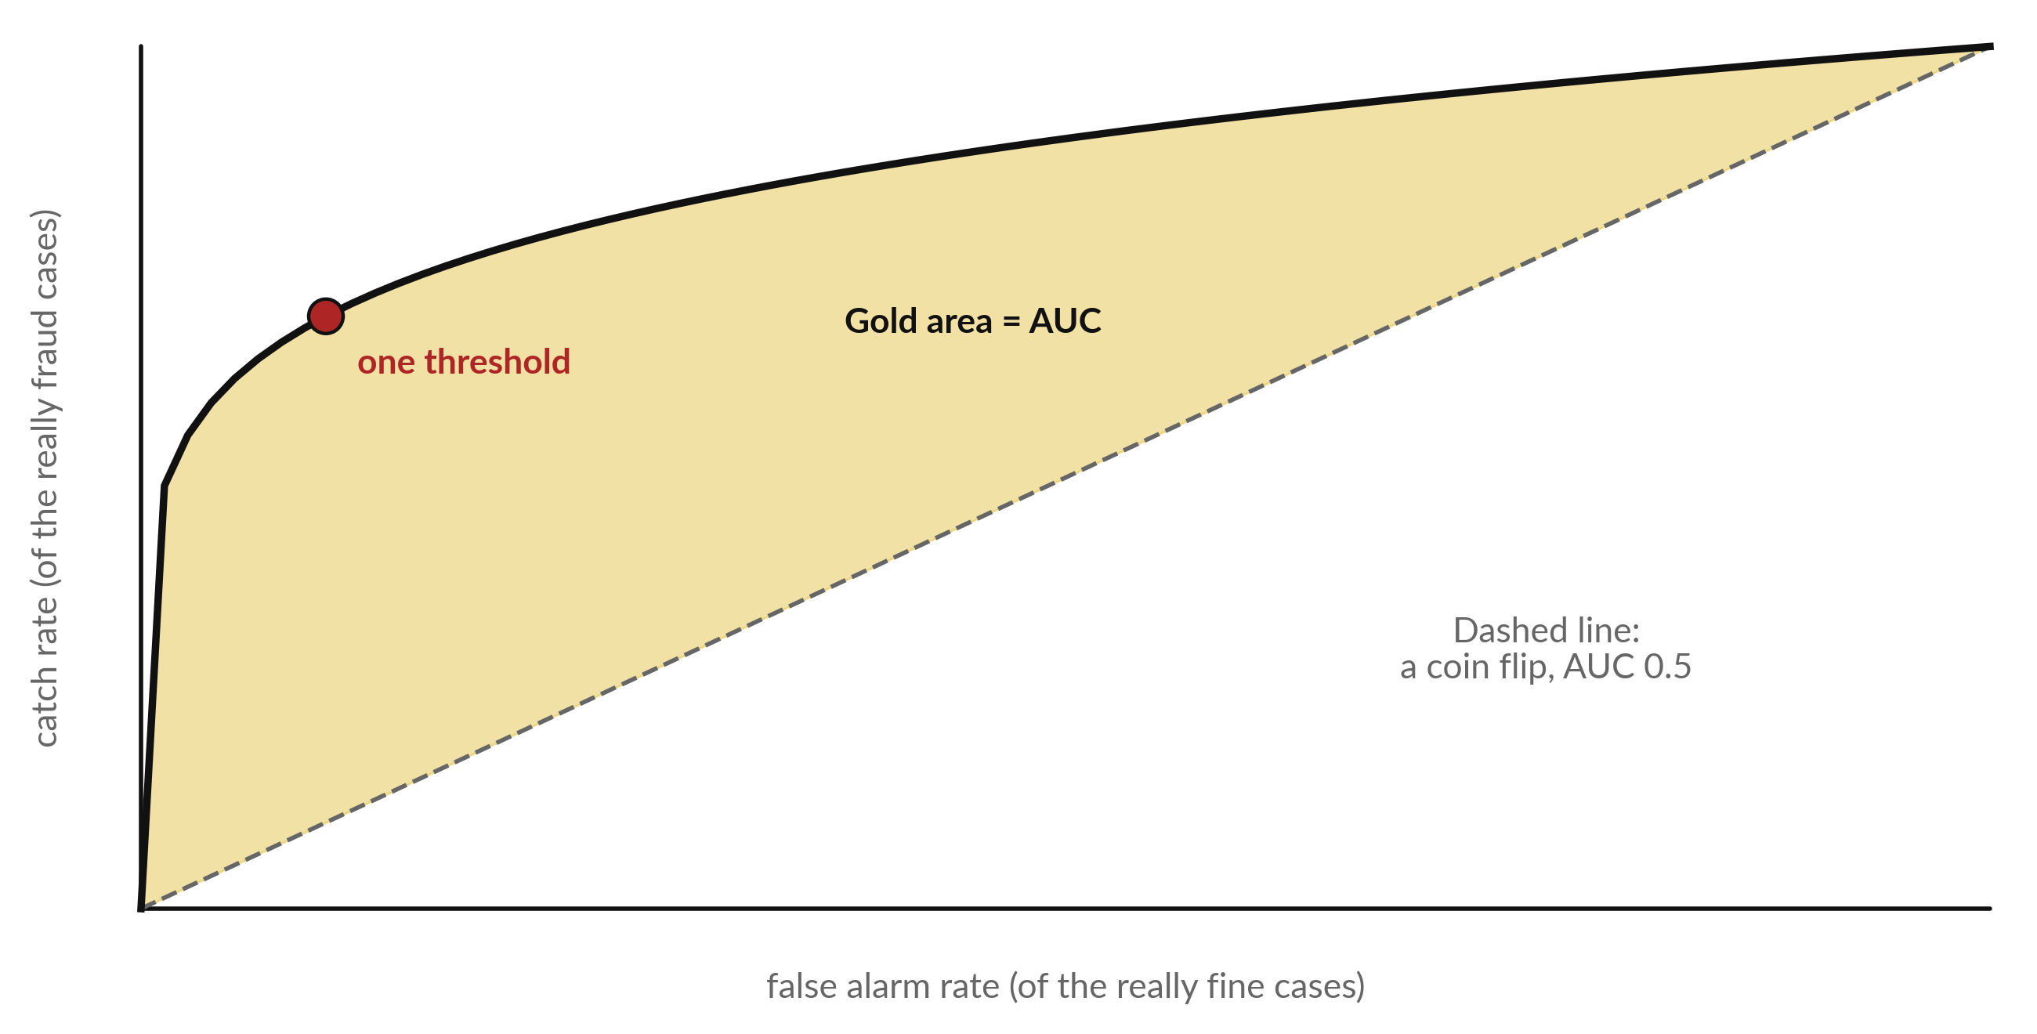
Illustrative ROC curve. The diagonal is a coin flip. The further the curve bows toward the top left, the better the model.
Measures for models that give a number
Measure | In plain words
MAE (mean absolute error) | On average, how far off the forecast is, in the same unit as the thing forecast. If the MAE is 20 bags of rice, the forecast is typically 20 bags away from the truth.
RMSE (root mean squared error) | Like the MAE, but a big miss counts for much more than a small one. Use it when large errors hurt most.
R squared | How much of the ups and downs in the real numbers the model explains. 1 means all of it, 0 means none.

Measures for ranking and recommendation
When a system suggests a list, such as products to offer a shop, a simple measure is the top-k hit rate: in how many cases was what the customer really wanted among the first k suggestions? With k = 5, a hit rate of 60 percent would mean that in 6 cases out of 10 the right item was in the top five.
Measures for language models
A language model writes free text, so there is no single right answer to count. Five checks are in common use.
Check | The question it answers
Benchmarks | Public sets of standard questions (see the next part). Useful for a first comparison.
Human review | People read the answers and rate them against a short checklist. Slow, and the most trusted.
Groundedness | Does every claim in the answer come from the documents the model was given?
Citation accuracy | Does each cited passage exist, and does it say what the answer says it says?
Hallucination rate | How often does the answer contain something invented?

For your own work, build a small test set from your own documents: a few dozen real questions with answers you have checked. Run the tool on them and count the results. No public benchmark can tell you how a tool does on your contracts, your reports and your words.
Questions to ask about any quoted figure
1. Measured on which data? Was it data the model had never seen, and does it look like ours?
2. At which threshold? A figure at one threshold says little about another.
3. What does a miss cost us, and what does a false alarm cost us?
4. Compared with what? How does the task get done today, or by a very simple method?

Part 10
Benchmarks
A benchmark is a set of standard test questions given to many models, so that their scores can be compared. You will see them in vendor announcements.
• MMLU tests broad knowledge across many school and professional subjects, by multiple-choice questions.
• HumanEval tests coding: the model writes small programs, and the programs are run to see whether they work.
• Chatbot Arena a public site where people compare two anonymous answers and vote for the better one. The votes build a ranking of human preference.
Limits of benchmarks
• Contamination. If the test questions were in the text the model learned from, the model may have seen them. The score then overstates what it can do.
• Who ran it. A vendor-run score deserves less weight than an independent one. Ask who ran the test and whether others can repeat it.
• Your task is different. A model that is strong on school-style questions may be weak on your contracts, your language or your forms.
Use benchmarks to shortlist two or three candidates. Then test those candidates on your own documents, with your own questions, before you decide.

Part 11
Training and inference
Two words describe the two phases of a model's life. Costs and skills differ in each.
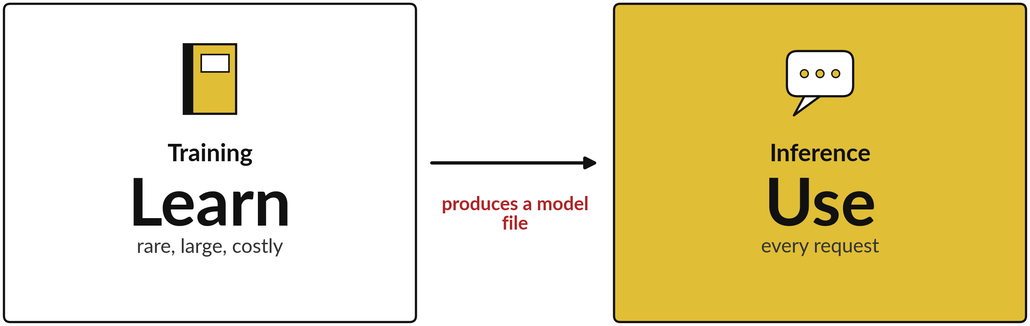
Training makes the model file once. Inference uses the file again and again.
 | Training | Inference
What happens | The model learns its settings (weights) from data. | The finished model answers a new request.
How often | Rarely: once, and again when the model is updated. | Every time someone asks.
What it needs | Large data and a great deal of computing power. | Fast, reliable serving, so that answers come back quickly.
What it produces | A model file. | An answer.
Where the cost sits | A large one-off cost, paid by the model maker. | Billed per use, which is the cost you pay and which grows with your volume.

Part 12
What happens when you press send
You type a question and press send. An answer appears in seconds. This part opens the box. The steps are simplified, and each product differs in the details.
A plain message
• 1. Split. Your text is cut into tokens.
• 2. Predict. The model predicts the most likely next token, adds it, and predicts again, over and over, until the answer is complete.
• 3. Check and send. The reply is checked by the provider's safety rules and streamed back to you as it is produced, which is why the words appear one after another.
A message with a document
When you also upload a document, more happens before the model writes anything. This is the pipeline behind a "chat with your documents" tool.
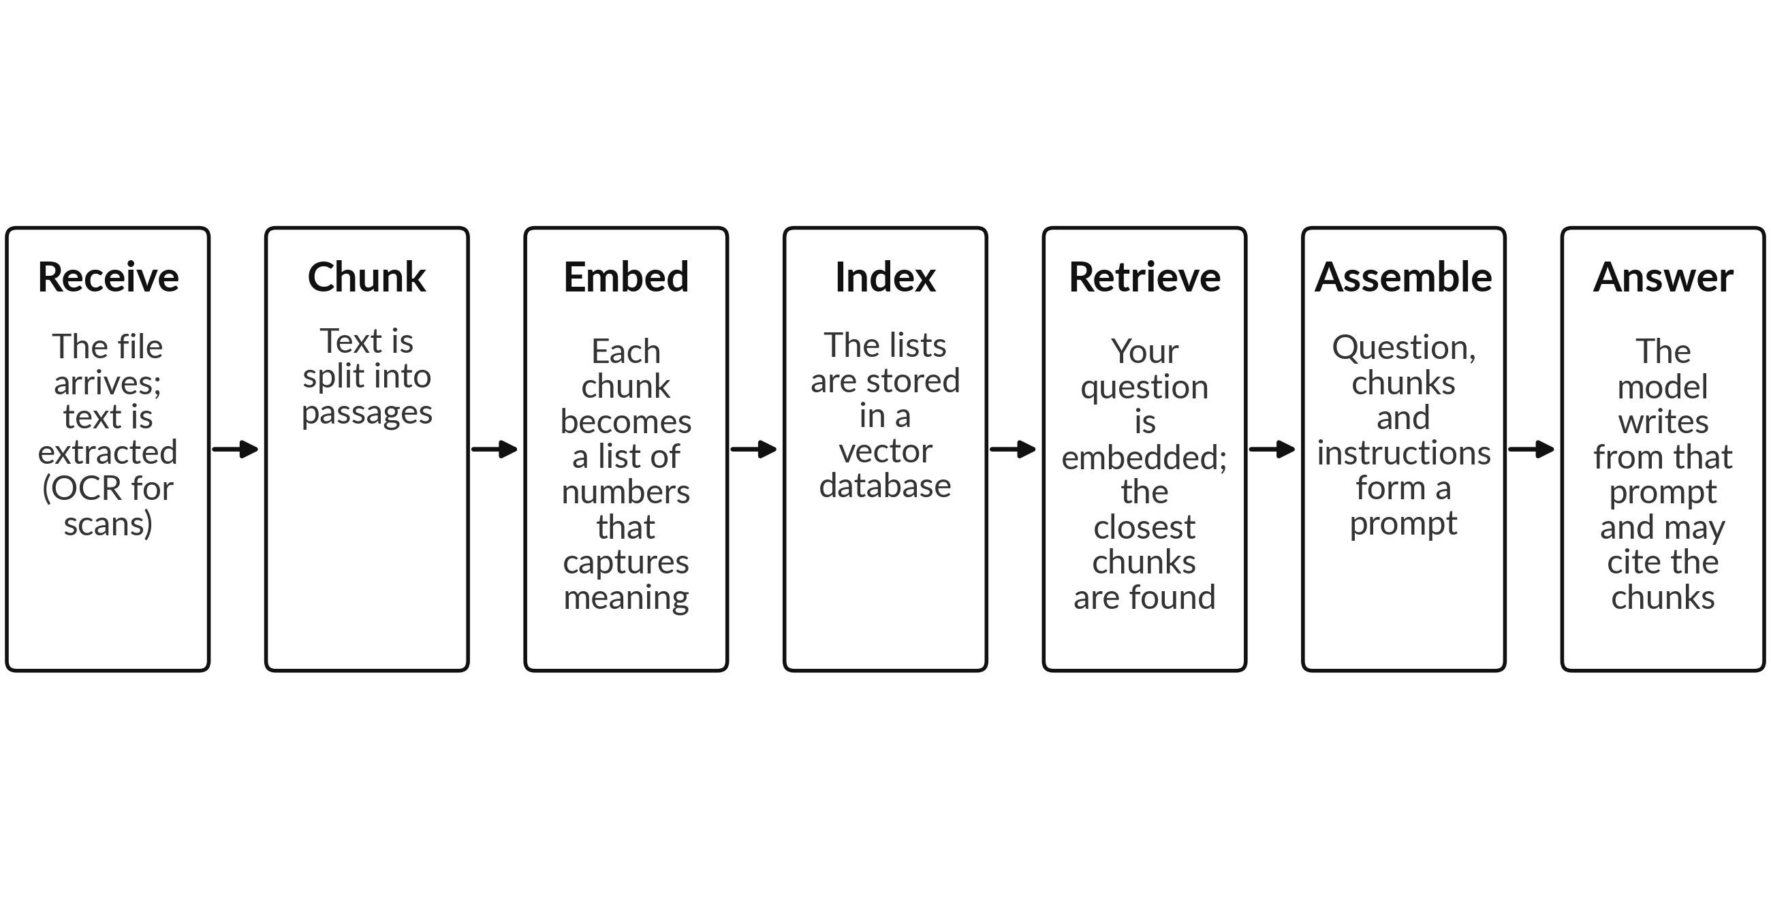
The seven stages of a retrieval pipeline, read left to right. The first four happen when the file is added. The last three happen on every question.
An embedding is a list of numbers that captures the meaning of a passage, so that passages with similar meaning sit close together. A vector database stores these lists and finds the closest ones to a question quickly. Products differ: a short file may simply be placed whole in the context window, and only long files go through retrieval. The exact pipeline is the vendor's, so ask.
Stage | What it does | What can go wrong
Receive and extract | Reads the file and pulls out the text. A scan needs optical character recognition (OCR). | A scan is misread: a 3 becomes an 8, a stamp covers a line, a table loses its columns.
Chunk | Cuts the text into passages of a workable size. | A clause is split across two chunks, so neither chunk holds the full meaning.
Embed | Turns each chunk into numbers that capture meaning. | Rare terms, names and codes are captured poorly.
Index | Stores the embeddings so they can be searched. | A stale index: the document changed but the index did not. Permissions are ignored, so a person sees a passage they should not.
Retrieve | Finds the chunks closest in meaning to the question. | The wrong chunk is retrieved, and the model answers confidently from the wrong page.
Assemble and answer | Builds the prompt and generates the answer, possibly with citations. | The model misreads the right chunk, or a citation points to a passage that does not say that.

Part 13
Foundation models, open models, fine-tuning and cost
A foundation model is trained once on broad data and then adapted for many tasks. Few companies train one. Most use one. The questions for you are which kind to use, how far to adapt it, and what it will cost to run.
Proprietary and open-weight models
A proprietary model is reached by subscription or through an API, and the maker keeps the model file. An open-weight model can be downloaded and run on your own machines. Be careful with the words "open source": the licence of an open-weight model may limit how you use it, so read the licence.
 | Proprietary | Open-weight
Set-up effort | Low: sign up and start. | Higher: you set up the servers and the software.
Control of data | Your data goes to the provider. Check the terms and where it is processed. | Data can stay on your own machines.
Quality | Often the strongest general models. | Improving fast; strong for many tasks, a gap on some.
Skills needed | Little technical skill. | Engineers who can run and secure the model.
Running cost (kind) | Pay per use or per user. | Computers and people, whether or not the model is busy.
Who maintains it | The provider. | You, or a partner you hire.

Four ways to get a model to do your task
Fine-tuning teaches style and skills. Retrieval supplies facts. Most business needs start with prompting and retrieval.
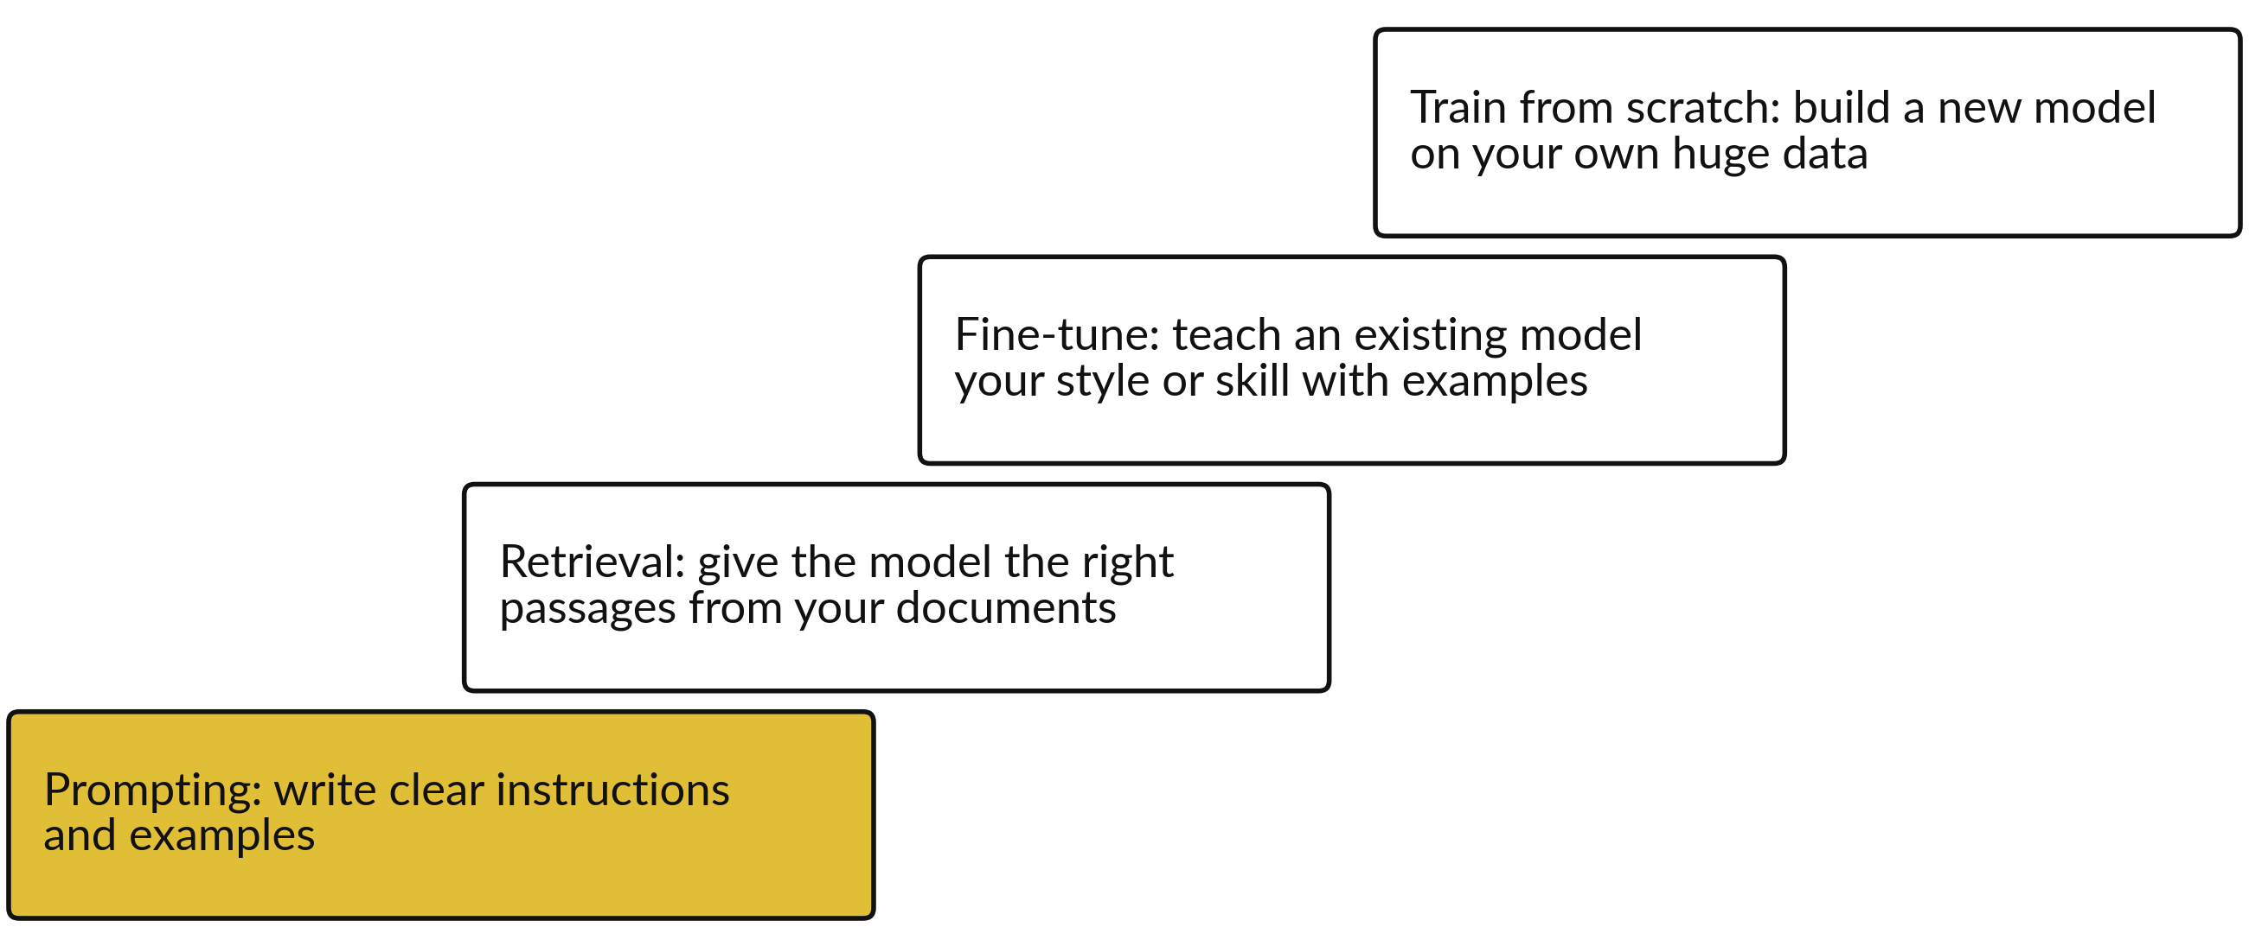
Start at the bottom. Move up only when the step below cannot do the job.
Method | What it changes | When to use it | Effort
Prompting | The instructions the model sees. | Always the first step. | Hours
Retrieval | The facts the model can see when it answers. | The answer must come from your own, changing documents. | Days to weeks
Fine-tuning | The model's style, format and skills. | You need a steady tone or format that prompts cannot give, and you have good examples. | Weeks, with specialists
Training from scratch | Everything. | Almost never for a company. | Months, large teams and data

Where AI costs come from
The model fee is one of several costs. A business case that counts only the fee will come out too low. This stack shows the parts. No figures are given, because each depends on your plan and your volume.
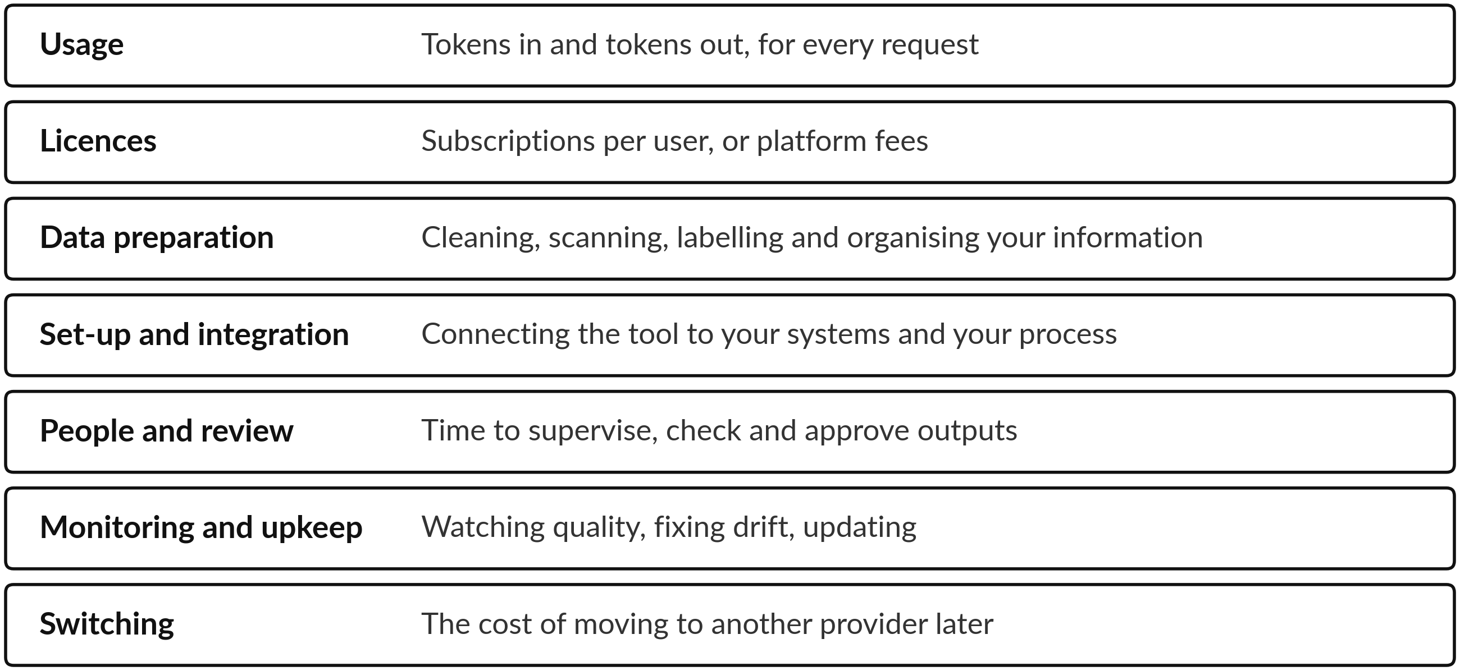
Seven kinds of cost. Session 11 puts them into your business case.

Part 14
Is our data ready for AI?
A tool is only as good as the information behind it. Consider a law firm that holds thirty years of decisions and rulings. They exist as paper files in a records room, scanned PDFs of mixed quality on a shared drive, Word documents, emails, and a spreadsheet index that someone started years ago. The firm wants an assistant that finds the right ruling in seconds. Can it do that today? The scorecard below shows how to find out.
The readiness scorecard
Check | The question | The red flag
Inventory | Do we know what we hold, and where? | Nobody can say how many documents there are, or where they sit.
Format and quality | Can a machine read it? | Crooked, faint or handwritten scans; text that OCR reads wrongly.
Completeness and duplicates | Is each decision present once? | Five copies of one ruling in different folders, or pages missing.
Metadata | Is each file labelled with court, date, judge, parties and citation? | File names such as "scan0042.pdf" and no labels at all.
Rights and confidentiality | May we use it, and who may see it? Is client privilege protected? | Privileged client files mixed in with public rulings.
Currency | Is it up to date? Are overruled decisions marked? | An overruled decision is returned as good law.
Structure | Does it have headings, sections and paragraphs we can rely on? | One long block of text with no divisions.
Access and ownership | Who owns it, and who can open it? | Everyone can open everything, or nobody is responsible for it.

Six preparation steps
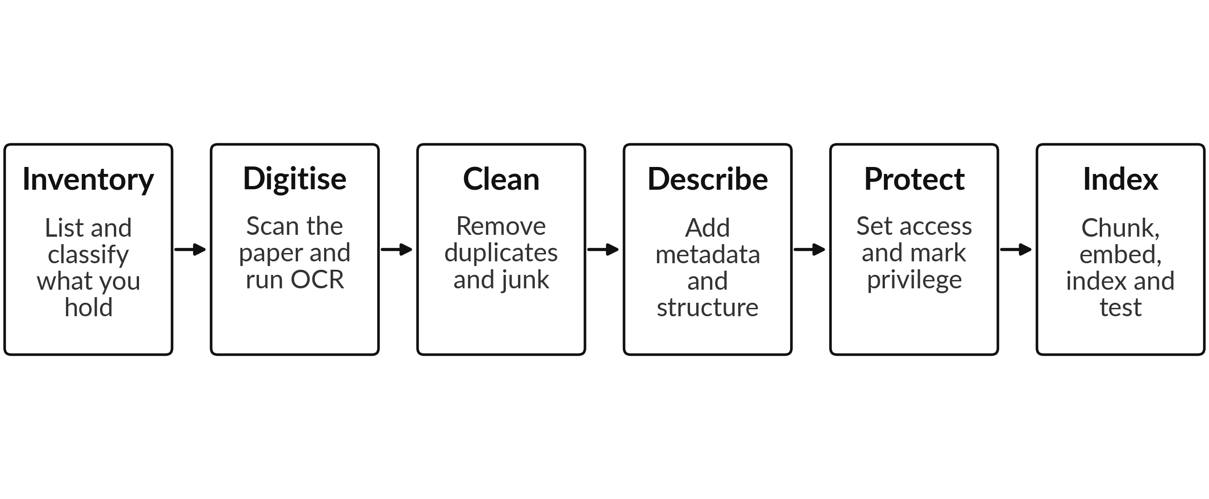
Six steps, left to right, from a records room to a searchable collection. Step 6 is the pipeline from Part 12.
How to test the result
Write about 50 real questions to which you already know the answers, drawn from the work lawyers really do. Run them through the tool and record four things.
• Retrieval. Was the right passage found?
• Faithfulness. Does the answer say what the passage says, and nothing more?
• Citations. Does each citation point to the right decision and the right place in it?
• Time saved. How long did it take compared with the usual way?
Fix the weakest step, run the same questions again and compare. This test set also protects you later, because you can rerun it whenever the tool or the documents change.
Preparing data to train or fine-tune a model
Preparing data to train or fine-tune a model is a different job from preparing it for retrieval. The steps are:
• Collect data that you have the right to use for this purpose.
• Clean it and remove personal data.
• Filter for quality: drop poor, wrong or repeated material.
• Format it as examples, such as question and answer pairs.
• Split it into training, validation and test sets.
• Tokenise it, which means cutting it into tokens the model reads.
• Train, then evaluate on the test set.
This asks for more data, more skill and more money, and the result is a model that has absorbed your documents in a way you cannot easily inspect or correct. For this reason most organisations should prepare for retrieval first. Retrieval keeps each fact tied to its source, lets you delete or update a document, and works with the model you already use.

Part 15
From model to working product
A model on its own does nothing for a company. It becomes useful when it sits inside a process that people use and look after. The life of a working AI system goes round in a cycle.
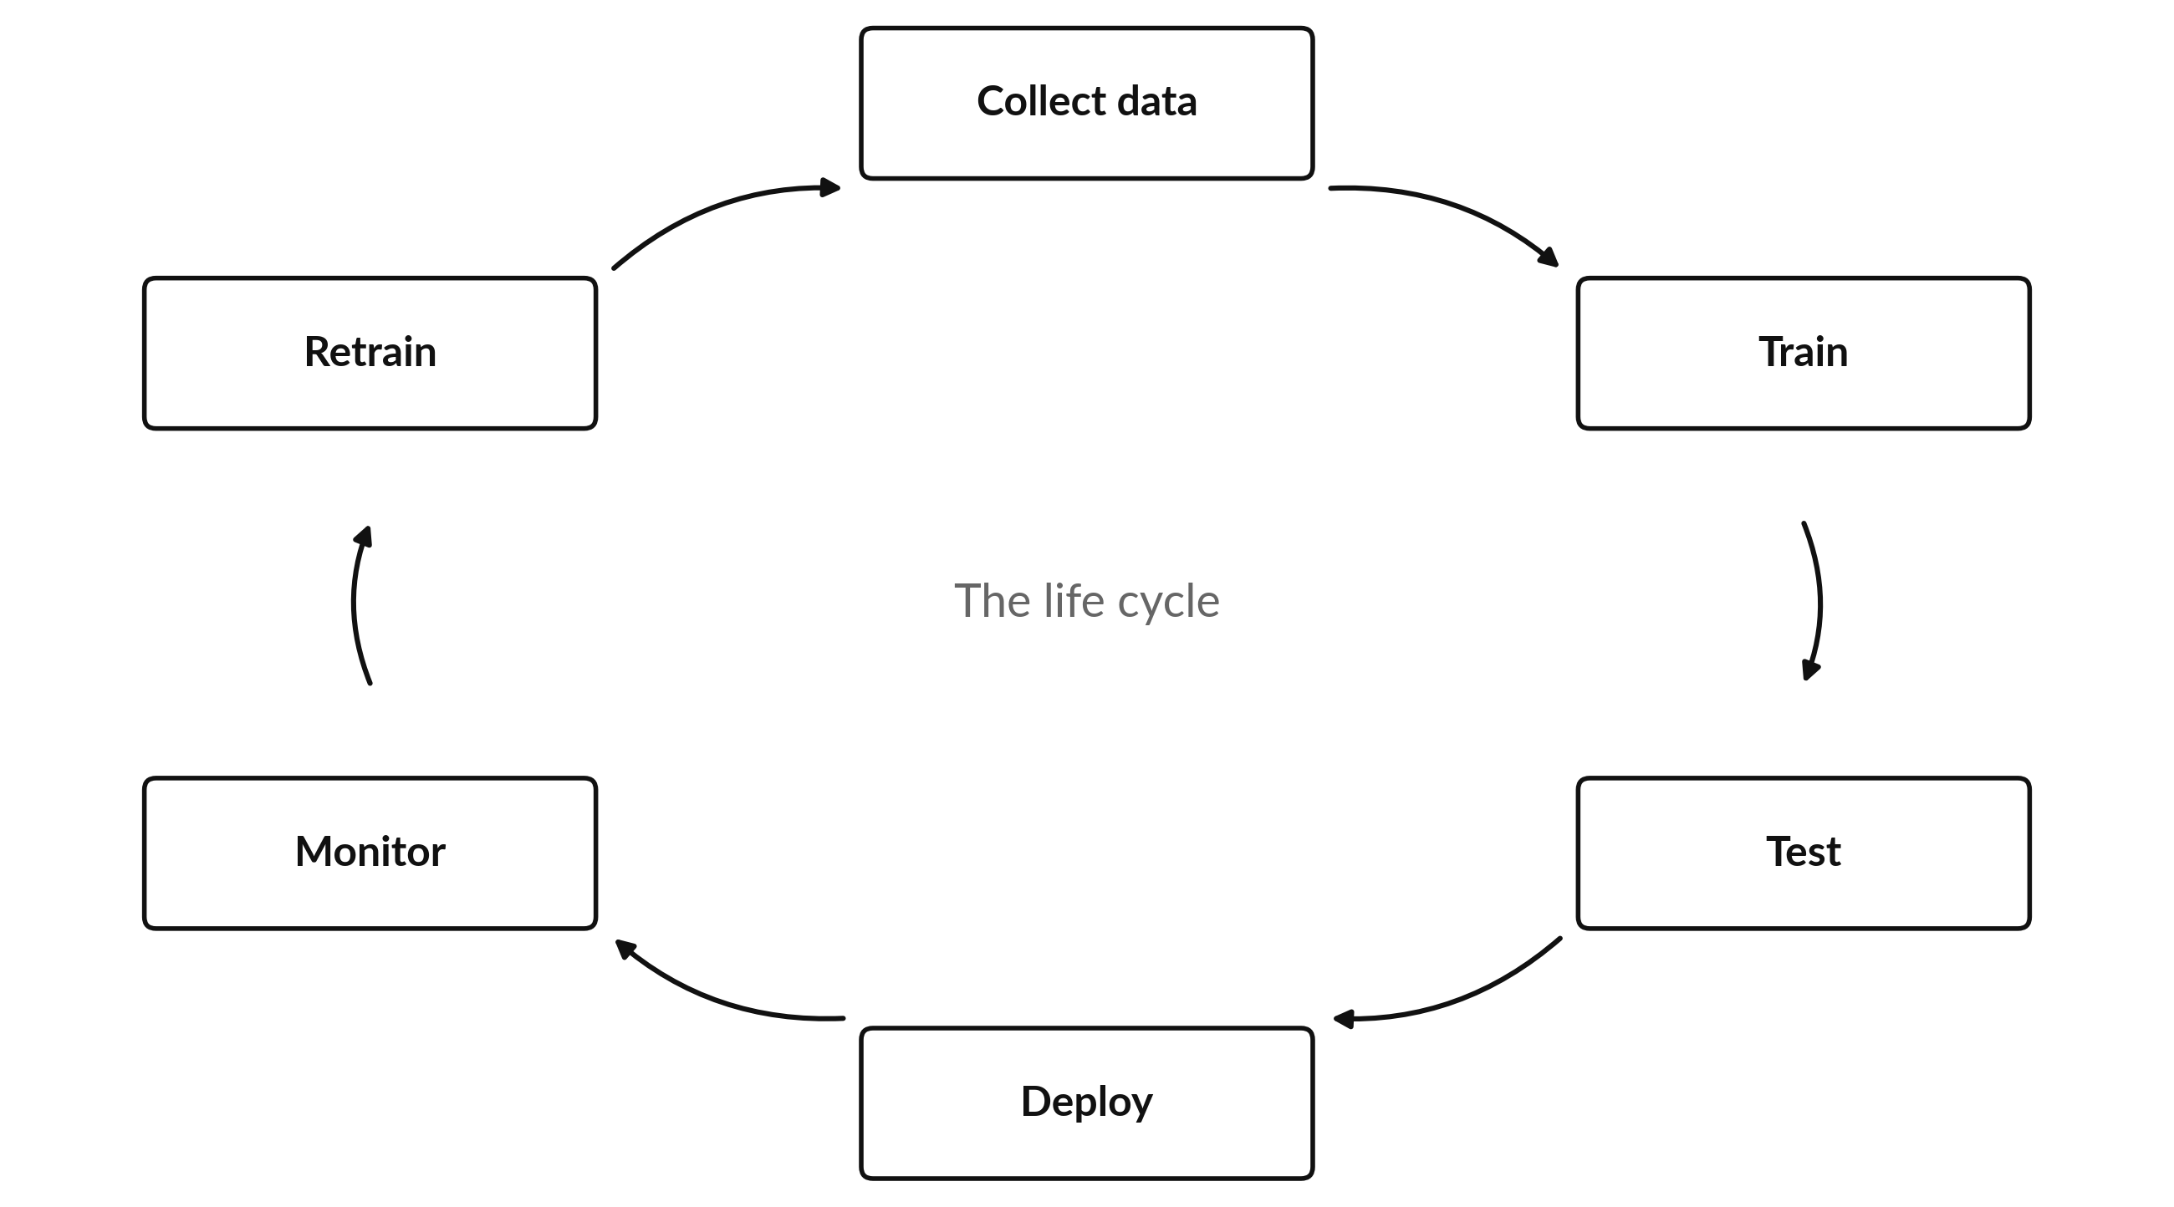
Deploy means put it to work. Monitor means watch the results. Drift is when the world changes and the model slowly gets worse, which is why retraining is part of the cycle.
Models, workflows and agents
Three levels of automation are easy to mix up. Each gives the system more freedom, and so needs firmer limits.
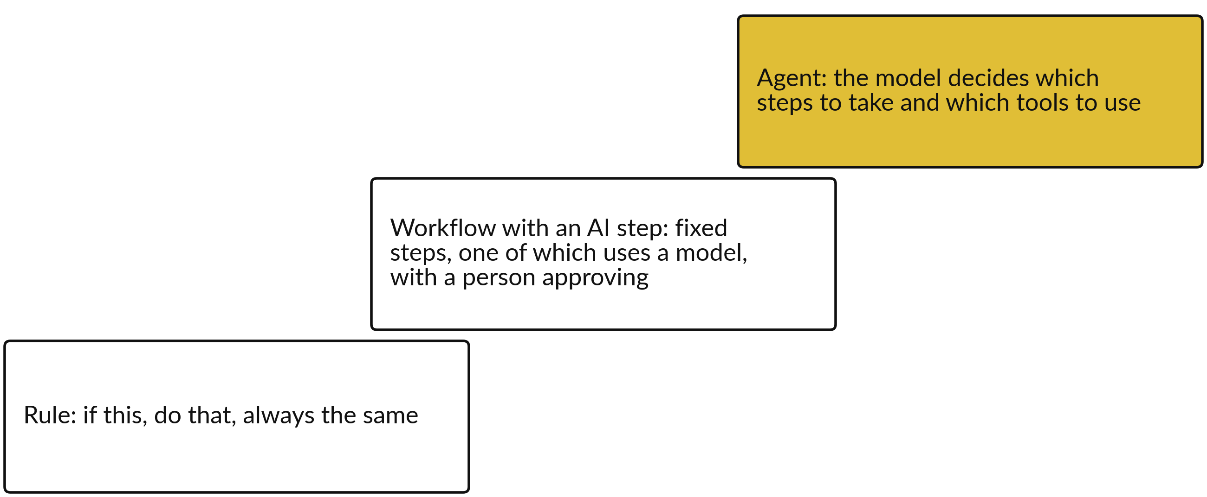
The ladder runs from the most predictable at the bottom to the most freedom at the top.
In Session 8 I show you the middle step: a workflow with an AI step and a person approving. Session 7 looks at agents. The more freedom a system has, the more it matters to set limits on what it may do and to keep a person approving anything that leaves the company, such as an email to a customer, a payment or a change to a record. A human in the loop is a person who must approve before the action happens.
Automation tools on the market
Many tools can build the same workflow. They differ in who they suit and how they charge. The list below says how each is billed in kind. It gives no prices, which change and depend on your plan.
Tool | What it suits | How it is billed (kind only)
Zapier | No-code connections between thousands of apps. Suits business users. Shown as an example in Session 6. | Per task (a task is one completed action step)
Make | Visual canvas with branches and detailed control. Suits people who like to see the whole flow. | Per operation
n8n | Flexible and technical. Can be run on your own server. Suits teams with a technical person. | Per execution (a run of the whole workflow) on its cloud
Microsoft Power Automate and Copilot Studio | Best when your company already runs Microsoft 365. Connects to Outlook, Excel, Teams. | Per user, or by usage credits
Agent builders in ChatGPT, Gemini and Claude | Build an assistant or agent for your own instructions and files, inside the assistant you already use. | Part of the assistant plan, with limits that vary by plan

Billing terms and plan limits change often. Check the current terms before you decide, and ask what happens to your data on each plan.

Part 16
Before Session 1
Session 1 starts with your own tasks, so a little preparation makes the first hour count.
What to prepare
• Choose three recurring tasks from your company. Pick work that comes round again and again: a weekly report, a daily batch of messages, a monthly reconciliation. Write each in one line, with how often it happens and about how long it takes. In Session 1 you choose one of them as your own task.
• Bring a laptop and one AI assistant account. Any assistant you already use will do, such as ChatGPT, Claude, Gemini or Copilot. The course does not need a paid plan.
• Have a Google account. A free Gmail account is enough. You need it for the sheets we use.
• Use only sample or invented data. In class and in practice, use made-up or sample information. The course gives you a fictional company, Nile Valley Foods Ltd, for this.
Ground rules for responsible use
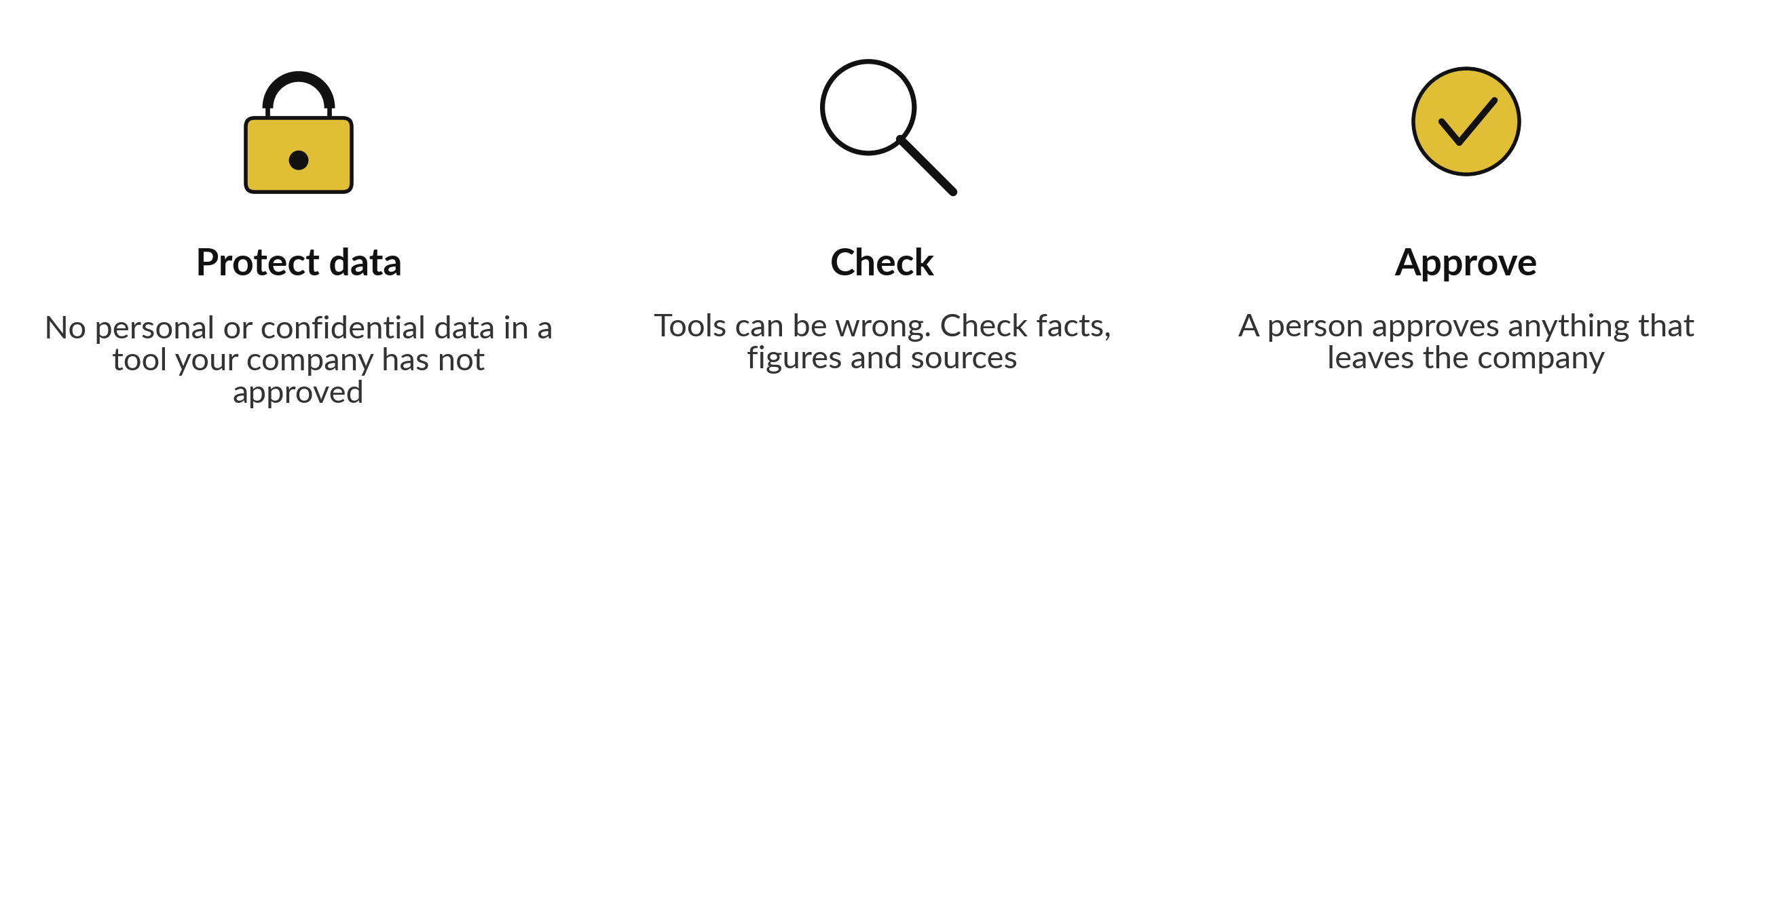
These three rules apply from the first session. Your own company's policy, which you write in Session 9, will build on them.
Questions to bring to Session 1
Which of my three tasks wastes the most time or causes the most errors?
Who else touches this task, and who would need to approve a change?
What would "better" mean for it, in a number I could measure?

Part 17
Glossary
Terms in plain words, from A to Z.
Term | In plain words
Accuracy | The share of all cases a model got right. It can mislead when the event is rare.
Agent | An AI system that decides for itself which steps to take and which tools to use to reach a goal. It needs firm limits.
AI literacy | Knowing enough about how AI works, where it fails and what rules apply, to use it and supervise it well.
Algorithm | A set of steps a computer follows to solve a problem or make a calculation.
API | A door that lets one program talk to another. A tool uses an API to ask an AI model for a result.
AUC | The area under the ROC curve. 0.5 is a coin flip and 1.0 is perfect.
Automation | Letting software do repeated steps without a person doing each one.
Backpropagation | The way a neural network shares out the blame for an error backward through its layers, so each weight can be adjusted.
Baseline | How the task is done today, with its time and error rate. You compare the automated version against it.
Benchmark | A set of standard test questions given to many models so that their scores can be compared.
Bias | A systematic tilt in a model's results that treats some cases or groups unfairly, often copied from the data.
Brief | A prompt written once in seven parts and reused. Session 3 teaches you to write one.
Chunk | A passage of a document, cut to a workable size so that it can be embedded and retrieved.
Classification | Learning to put each case into a category, such as fraud or fine.
Clustering | Finding groups of similar cases without being told the groups in advance.
Confusion matrix | A table of the four outcomes of a yes or no model: true positives, false positives, false negatives and true negatives.
Context window | How much text the model can keep in view at one time, including your question, files and its answer.
Deep learning | Machine learning with neural networks of many layers. It suits images, sound and language.
Drift | A model getting worse over time because the world has changed since it was trained.
Embedding | A list of numbers that stands for the meaning of a piece of text or an image, so that similar things are close together.
F1 | One number that balances precision and recall.
Feature | One piece of information the model uses as input, such as the amount of a payment or the day of the week.
Fine-tuning | Training an existing model a little more on your own examples so that it fits a particular style or task.
Foundation model | A large model trained on broad data that can be adapted to many tasks. Language models are one kind.
Governance | The rules, roles and checks that decide who may use AI, for what, and who answers when something goes wrong.
Gradient descent | Improving a model by taking many small steps that each make the error a little smaller, like walking downhill in fog.
Hallucination | A confident answer from a model that is false or invented.
Human in the loop | A person who must approve or edit before an automated action goes ahead.
Inference | Using a trained model to produce an answer for a new case. Training is learning; inference is using.
Label | The correct answer attached to an example, used in supervised learning.
Loss or error | A number that says how far the model's guess is from the right answer. Training tries to make it smaller.
Machine learning | Computer systems that learn patterns from data instead of following only hand-written rules.
MAE and RMSE | Measures of how far a number forecast is from the truth, on average. RMSE punishes big misses more.
Model | The result of training: a program whose behaviour comes from the numbers it has learned.
Neural network | A model made of layers of simple connected units, loosely inspired by the brain.
OCR | Optical character recognition: reading the text from a scan or a photo.
Open-weight model | A model whose file can be downloaded and run on your own machines. The licence may limit use.
Overfitting | A model learning its training examples too closely, so that it does badly on new cases.
Parameter or weight | A number inside a model that training adjusts. It sets how strongly one input influences the answer.
Pilot | A small, time-limited trial in real work, with a measure of success set in advance.
Precision | Of the cases the model flagged, the share that were truly positive.
Prompt | Anything you type or send to an AI model.
Prompt injection | Hidden instructions in an email, web page or document that try to make an AI tool do what its owner did not intend.
Recall | Of the truly positive cases, the share the model caught.
Regression | Learning to give a number as the answer, such as a forecast of sales.
Reinforcement learning | Learning by trial and reward: actions that pay off are repeated.
Retrieval | Fetching the relevant passages from your own documents and giving them to the model before it answers.
ROC curve | A curve that shows how catches and false alarms change as the threshold moves.
ROI (return on investment) | What you gain compared with what you spend, for example time saved against cost.
Supervised learning | Learning from examples that come with the right answers.
Threshold | The score above which a model raises an alert. Moving it trades false alarms against misses.
Token | A small piece of text, often a short word or part of a word, that a language model reads and writes.
Training | The process of adjusting a model's weights, using data, until its guesses are good.
Trigger | The event that starts an automation. In a Zap it is an event such as a new email. In Apps Script it is a timer or an event.
Unsupervised learning | Learning from data with no right answers given, by finding structure such as groups.
Validation and test data | Data kept apart from training. Validation data helps tune the model. Test data is locked until the end for a fair final check.
Vector database | A store of embeddings that finds quickly the ones closest in meaning to a question.
Workflow | A fixed series of steps, often across several apps, that runs when a trigger fires.

Part 18
The twelve sessions at a glance
No. | Session | You keep
1 | Where AI fits in your business | Use-case scorecard and one-page task card with baseline
2 | How AI works and where it fails | Reliability test record for your task
3 | Working with AI tools | A reusable brief and one checked result for your task
4 | Your information: is your data ready for AI? | Information inventory, a scored readiness scorecard and your top three data gaps
5 | Reviewing documents with AI | A source-linked review table and a checking routine for AI output
6 | Automation 1: a rule-based workflow | You understand the routing rules, where they work and where they stop
7 | Agents and controlled actions | A tool boundary sheet and stop conditions; a choice of tool family
8 | Automation 2: an AI workflow | You can read the measured time and error comparison against your Session 1 baseline
9 | Your AI use policy | Risk register for your task and a first draft of your company AI use policy
10 | Buying and oversight | A vendor question list and a review of a sample proposal
11 | The business case | A costed business case workbook and a one-page summary
12 | Your data roadmap and 90-day plan | A data roadmap, a 90-day plan and the follow-up kit

Each session lasts two hours. After the course, the instructor follows up at 30, 60 and 90 days.
Jotham Martin Wambi | KLAi Professional Learning | jothammartin.wambi@gmail.com | +256 750 990 718

